Prediction Model Report
This document presents the different models and tests carried out using SPSS to predict accident severity. It outlines the steps taken to build and improve the decision tree model, including addressing issues such as class imbalance and refining the dataset. The results shown demonstrate how the model performance improved through these adjustments.
Test 1 Results:
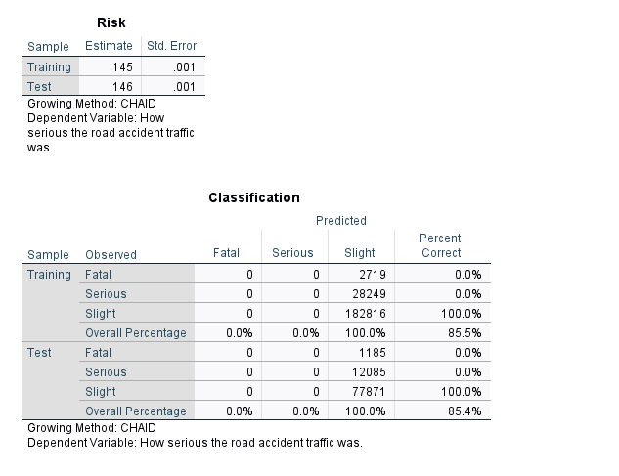
- Fatal -> predicted as Slight (0%)
- Serious -> predicted as Slight (0%)
- Slight -> predicted as Slight (100%)
The model is predicting every accident as “Slight”
The model is currently:
- Not predicting severity properly
- Ignoring Fatal and Serious cases
I have added the code below to hopefully tackle the balance of severity
RECODE accident_severity (1=1) (2=1) (3=0) INTO severity_binary.
EXECUTE.
The initial model showed high overall accuracy (85%), however, further inspection revealed that the model predicted all cases as “slight” accidents. This indicates a class imbalance problem, where the model favoured the majority class and failed to correctly classify severe accidents. To address this, the severity variable was recoded into a binary outcome (severe vs slight), improving model performance.

Test 2 Results
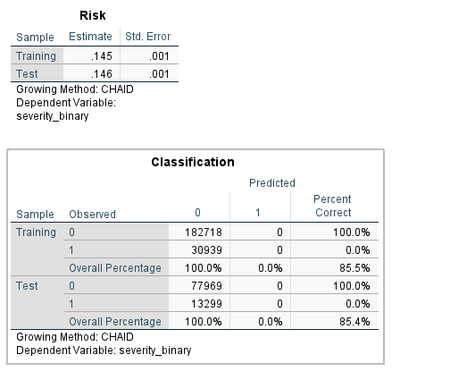
Even after fixing severity:
- All predictions = 0 (Slight)
- No cases predicted as 1 (Severe)
The model initially achieved high accuracy (85%), however, it failed to correctly classify severe accidents, predicting all cases as slight. This highlights a class imbalance issue within the dataset.
To address this, data balancing techniques were applied:
I have added the following code below to counter balance issues:
COMPUTE severe_flag = (severity_binary = 1).
COMPUTE rand = RV.UNIFORM(0,1).
EXECUTE.
SELECT IF (severe_flag = 1 OR rand < 0.15).
EXECUTE.
Due to software limitations, a Random Forest model was not available, therefore we switched to a Classification & Regression Tree model (CRT)
Test 3 Results:
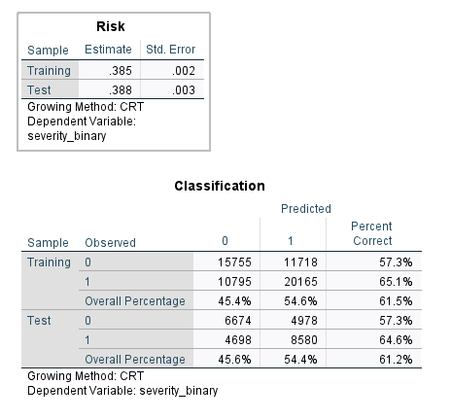
A classification and regression tree (CRT) model was used to predict accident severity. Initial models using CHAID were affected by class imbalance and predicted only the majority class, resulting in poor and unreliable predictions.
To improve this, the dataset was balanced and the modelling approach was changed to CRT, as it handles continuous variables more effectively and produces more accurate splits for prediction tasks.
After these improvements, the model was able to classify both severe and slight accidents rather than predicting only one outcome. The final model achieved an accuracy of approximately 61% on the test data. It performed better at predicting severe accidents (64.6%) compared to slight accidents (57.3%). The similar performance between the training and test datasets indicates that the model generalises well and is not overfitted.
Overall, the final model represents a clear improvement compared to the initial approach, as it produces balanced and meaningful predictions rather than biased results.

